Curriculum Vitae

(A) Personal Data:

Name: Zeinab Mahmoud Kadry Taie
Date and Place of Birth: 8/8/1986 Sohag, Egypt
Marital Status: Married
Language: Native Arabic, good English.
Address: Sohag, Egypt
Email: Zeinabmahmoud448@gmail.com

(B) Academic Degrees:

1. Master’s Degree in medical biochemistry (M.Sc.), (Thesis; study of the Apelin and Nitrous oxide in Essential hypertensive patients it is accepted locally and published in 2015 and it accepted internationally to be published later), Faculty of Medicine, Sohag University, Sohag, Egypt, 2015.

2. M.B, B.CH. Faculty of medicine, Sohag University, Sohag, Egypt, September 2009.

(C) Academic Positions:

1. Assistant lecturer in Medical biochemistry Department, Faculty of Medicine, Sohag University, Sohag, Egypt (October 2015 – now).
2.Demonstrator in Medical biochemistry Department, faculty of Medicine, Sohag University, Sohag Egypt (April 2012-october 2015)

3. Resident of Medical oncology department, Faculty of Medicine, Sohag University Hospital, Sohag (March 2011 - April 2012).

4. House Officer (A Multi-Specialty Rotating Internship) (March 2010 - February 2011): at faculty of Medicine, Sohag University Hospital, Sohag.

(D) Scientific Meetings Attended:

- The faculty of medicine conference of biochemistry, Sohag University, Sohag, May 2014.

- The Annual Scientific Meeting of in born error metabolism, Assuit University, Assuit, March 2017.

(E) Teaching Experience:

Teaching practical courses to undergraduate medical students.

(F) Special Interest:

- Medical biochemistry

- Molecular biology

(K) Publications & Research Activities
- The master thesis: "study of The Apelin and Nitrous oxide in Essential Hypertensive patients published in (Egypt. J. Biomed. Sci. Vol. 48,

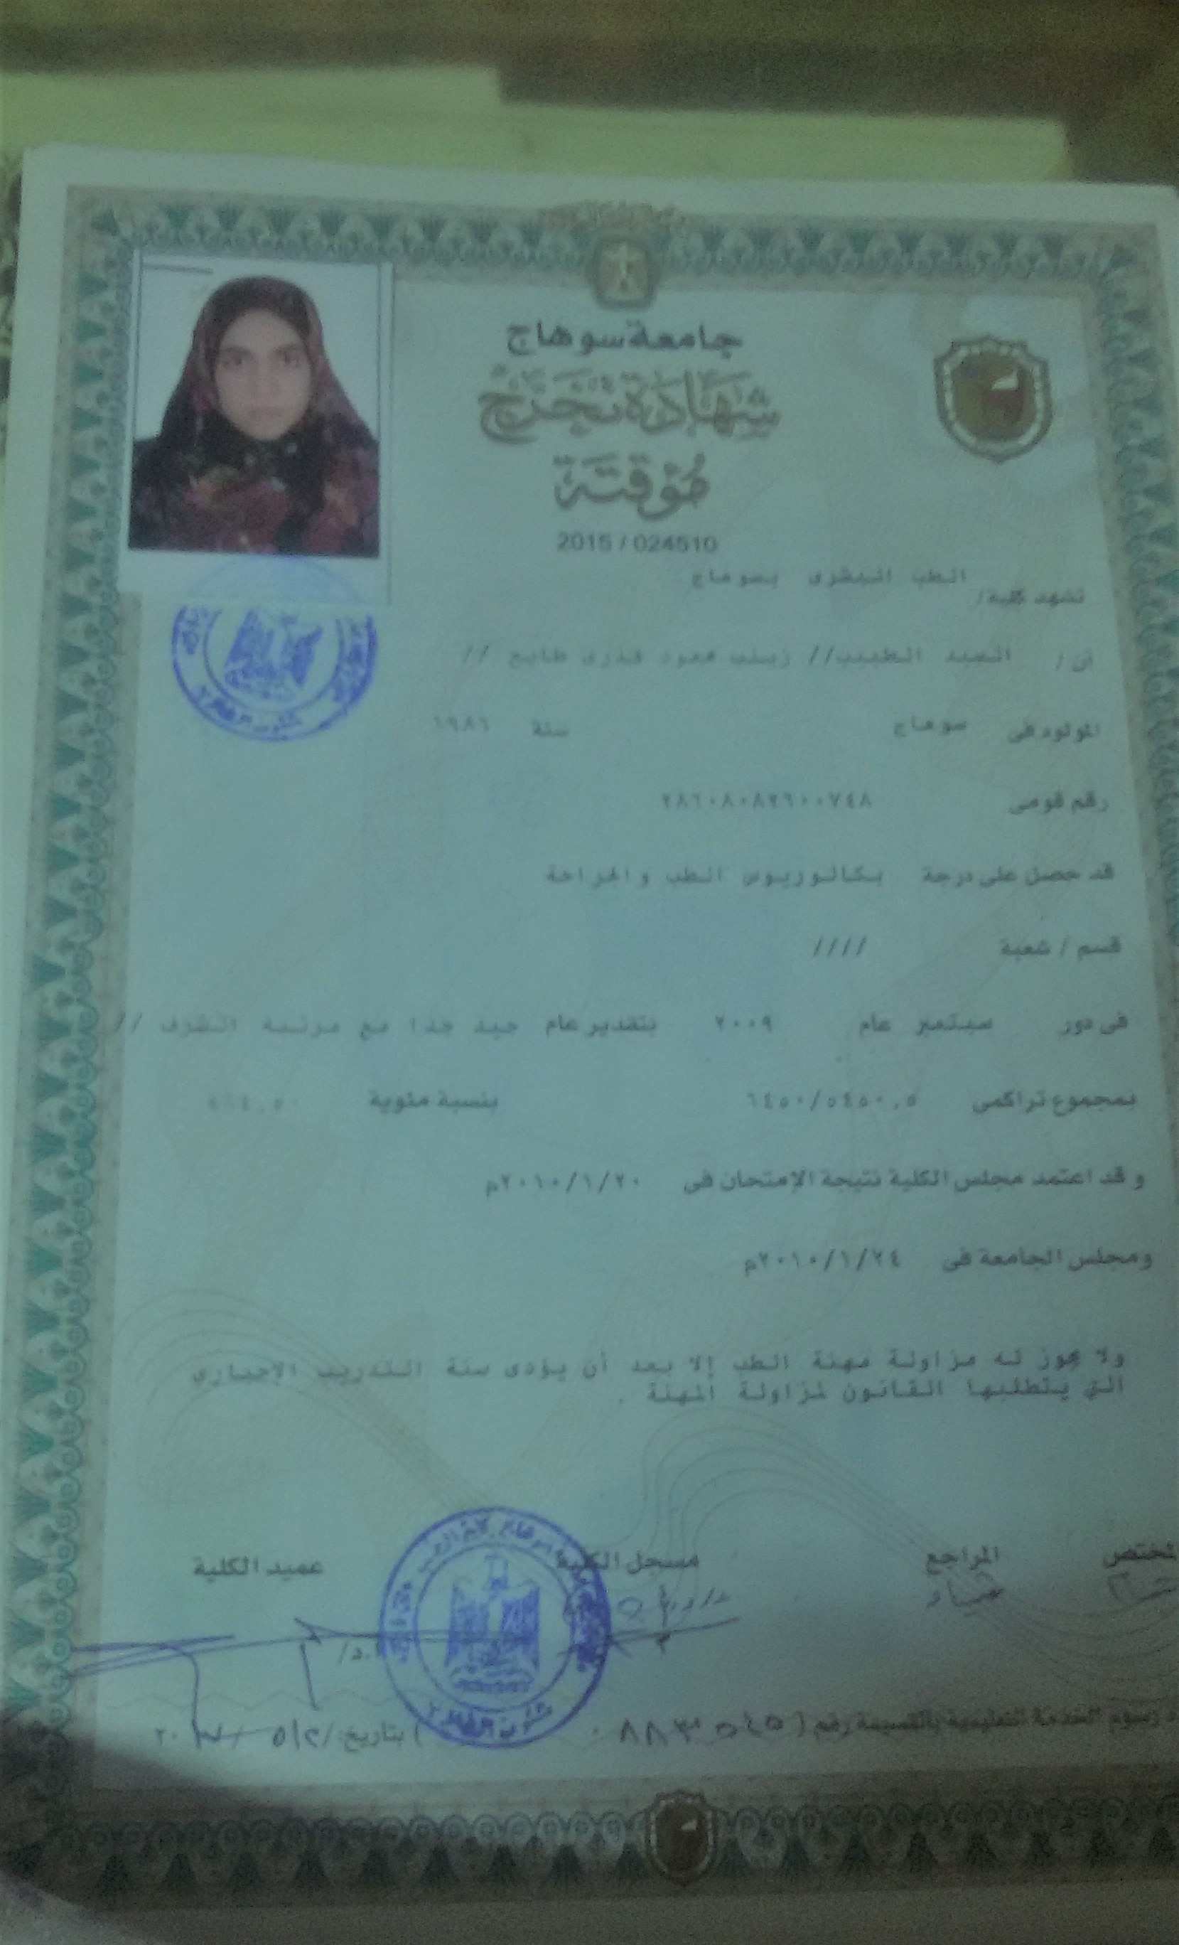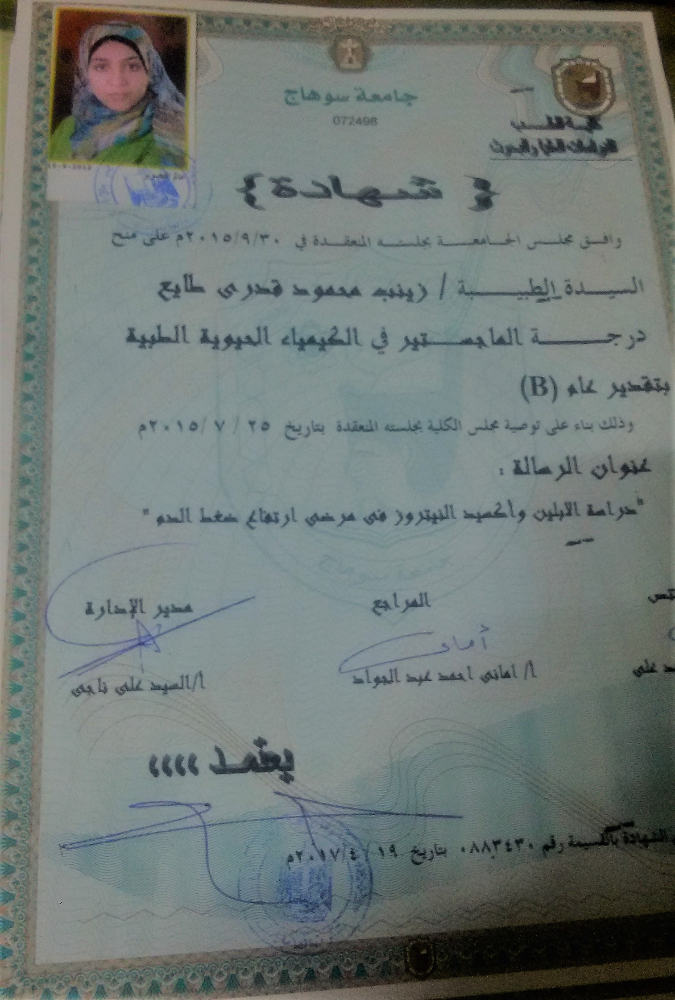

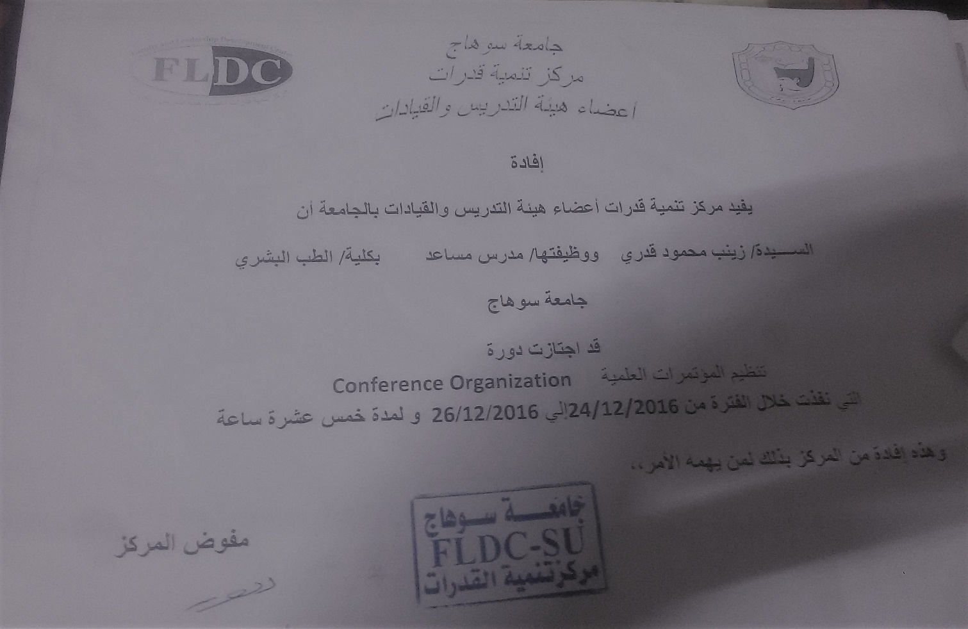 2015)

